Religions including shamans

Most of these religions are indigenous, but the idea of shamans has influenced other religions and philosophies if we decide none of these are a good fit for the game.

## General Capabilities

Shamans have many powers and traditions that differ, but the goal is to reach religious ecstasy as part of religious mysticism. *This means*, generally, they are **possessed** with the following abilities (through ritual):

* Speaking to the dead
* Healing
* Receive guidance and help from a guardian spirit (could be an animal or human)
* Combat (specifically between two shamans in which they fight in animal form)

Learn more [here!](https://www.britannica.com/topic/shamanism/Shamans-outside-of-northern-Asia)

## Other Related Religions

The following are religious that believe in similar concepts in which we could draw from:

Animism: attributing sentience to other beings including animals and the environment as well as inanimate objects.

Totemism: the belief that people have kinship or related mystical relationships with spirits that could be plant or animal.

Divination: The practice of foreseeing the future, done through omens, tarot, horoscopes, tea leaves, Ouija Boards, etc.

## Tengrism

Found in Mongolia and Turkey, Tengrism is “composed of three realms: the underground, middle realm inhabited by human beings, and the upper spiritual realm”.

Abilities/Beliefs:

* Act as spiritual in-betweens, traversing the “diverse echelons of the Tengriist cosmos”
* Help followers communicate with spirits from the 5th level of heaven
* Draws powers from their close connection to their sky god Tengri
* Strengthens and heals community from connection with forces of nature *and* guidance from Tengri

Symbols: World Tree (connecting three realms and nine directions of the universe)

Rituals:

* Made offerings of milk, alcohol, etc to gods they desire to communicate with

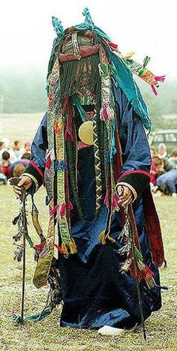 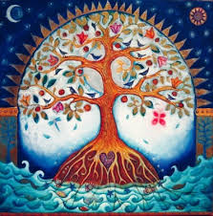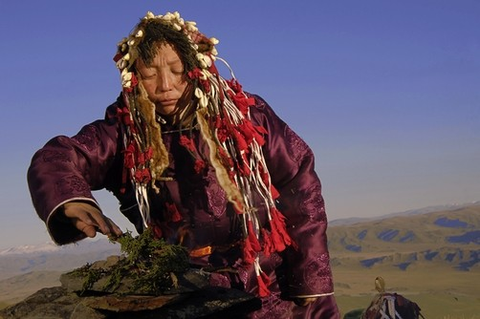 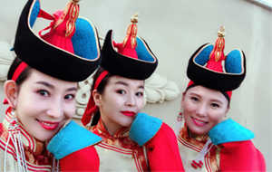

# Angákut

In North America, the Inuit and Yupik Indigenous groups had shamans, angákut, who performed ecstatic rituals for their community. Shamans in these groups are marked by their imbued supernatural power from personal experience.

Abilities/Beliefs:

* Sickness can be brought on by the corruption of a soul by a ghost
* “Magic flight”: some angákok have been to the moon or flown around the earth
* Prophecy
* Defend tribes from evil spirits

Symbols:

* Skeleton: symbol of rebirth

Rituals:

* Square dance: dance headed by angákok using a single-headed drum to commune with the spirits
* Vision quest: the initiation ceremony of prospective shamans

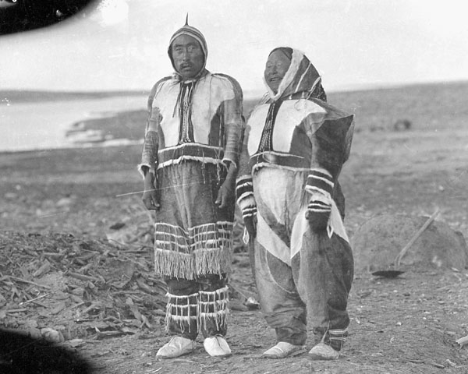 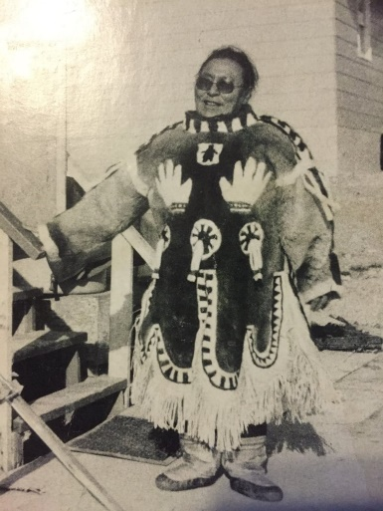 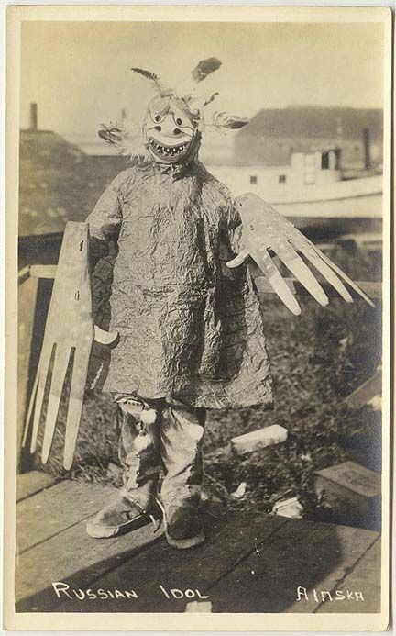

# Malayan Shamanism

Known in Malaysia as a *Bomoh* or *Pawang*, or in Indonesia as a *Duruk*, the Malayan Shaman has different worlds. Often times a shaman can be *Duruk* and subscribe to another religion like Islam.

Abilities/Beliefs:

* The *Bomoh* is primarily a healer and herbalist
* Summon spirits to fulfill requests at graveyards
* Spirits can heal as well as cast sickness and attack people.
* Settle conflicts
* *Pawang* deals with weather, nature, animals, and good harvest rituals
* Has spirits do his bidding and controls entities, find missing persons, or locate sources of bad luck

Symbols:

* Pawang have healing symbols

Rituals:

* *Mak Yong*: healing dance ritual to music played by an assistant *Tuk Mindk*
* *Jathilan* Dance: an offering to spirits as the *Pawang* shaman controls the spirit that possesses them.

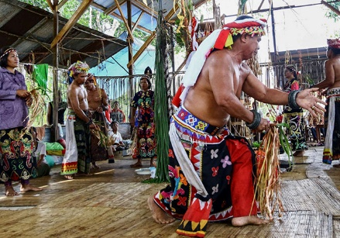 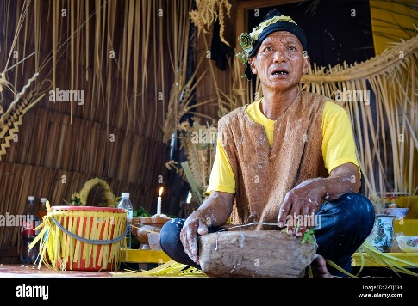 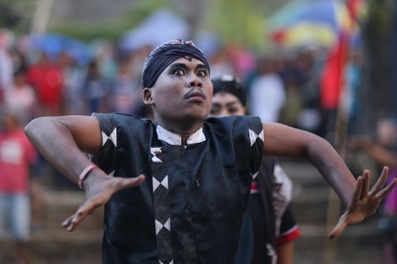

# Shintoism

In modern Shintoism, shamanism isn’t as widely practiced. The closest thing there is the Itako today. P.S. Old term – no longer considered shamans: Miko, shrine maiden priestesses.

Abilities/Beliefs:

* Itako: blind women who are known to heal through clearing spirits from the body
* Kannagi: gender-neutral shamans that communicate with spirits
* Talk with kami (deities)Rituals:
* Kagura dance: possession, trance-based shaman dance

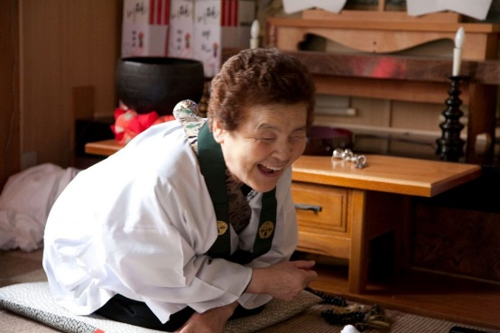 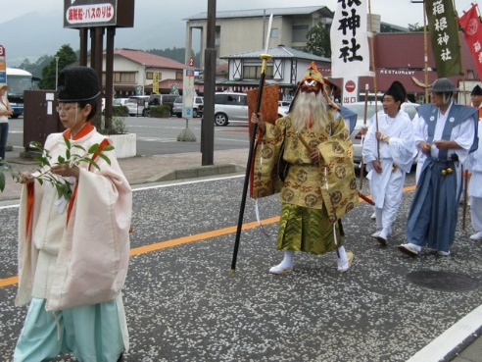

# Hmong Shamanism

Abilities/Beliefs:

* Communicates with supernatural beings and spirits
* See what is invisible to the average person
* Bring back information from the spiritual plane

Symbols:

* Pig jawbones: The number of pig jawbones conveys the number of healing rituals they’ve performed.
* Altar: The status of a shaman is determined by the size of their altar.

Rituals:

* Animal sacrifices (seen as one of the greatest honors for the animal, done on Hmong New Year)
* *Ua Neeb*: Diagnosing ritual that is supposed to determine the illness of a community member

